How to recover database in case of tablespace are corrupted and redo and control files are intact.

First delete SYSTEM01.DBF file

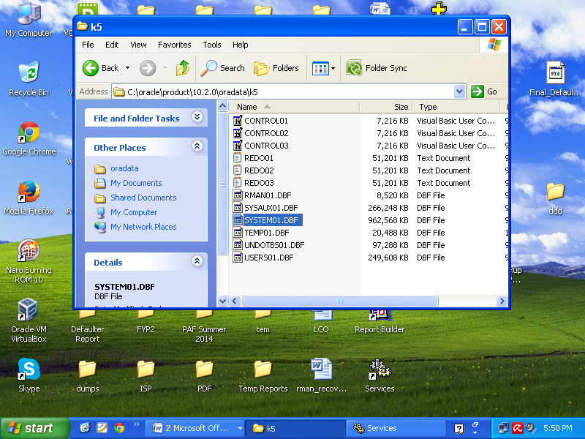

Now see the SYSTEM01.DBF is missing or might be corrupted.

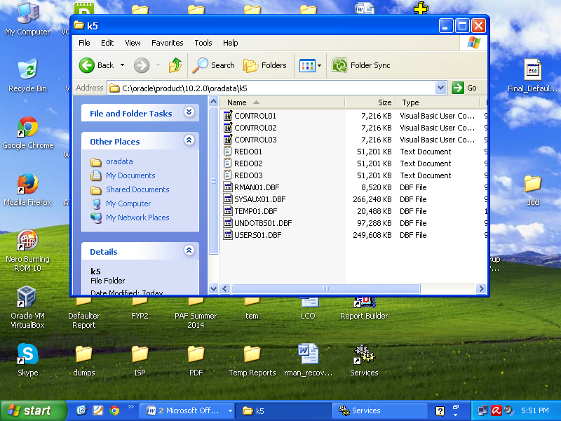

Now try to login

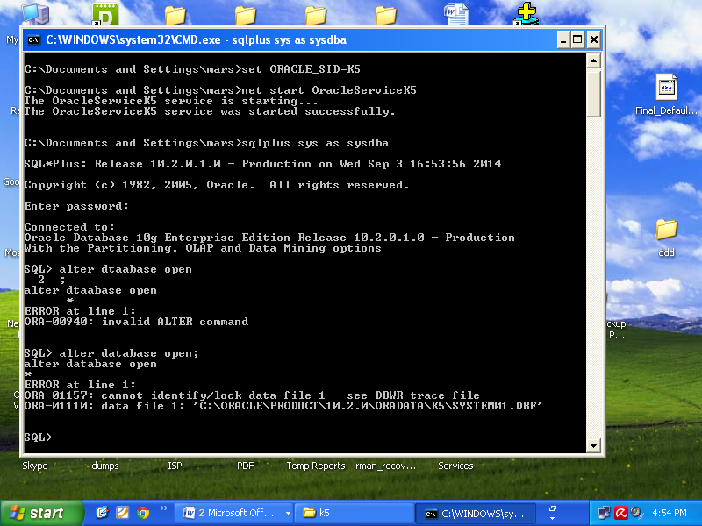

Now let’s play a game.

**C:\Documents and Settings\mars>rman catalog=rman/rman@k6 target=sys/sys@k5**

Recovery Manager: Release 10.2.0.1.0 - Production on Wed Sep 3 16:56:23 2014

Copyright (c) 1982, 2005, Oracle. All rights reserved.

connected to target database: K5 (DBID=3069599529, not open)

RMAN-00571: ===========================================================

RMAN-00569: =============== ERROR MESSAGE STACK FOLLOWS ===============

RMAN-00571: ===========================================================

RMAN-00554: initialization of internal recovery manager package failed

RMAN-04004: error from recovery catalog database: ORA-12514: TNS:listener does not currently know of service requested in connect descriptor

**C:\Documents and Settings\mars>set Oracle_Sid=k6**

**C:\Documents and Settings\mars>rman catalog=rman/rman@k6 target=sys/sys@k5**

Recovery Manager: Release 10.2.0.1.0 - Production on Wed Sep 3 16:57:23 2014

Copyright (c) 1982, 2005, Oracle. All rights reserved.

connected to target database: K5 (DBID=3069599529, not open)

RMAN-00571: ===========================================================

RMAN-00569: =============== ERROR MESSAGE STACK FOLLOWS ===============

RMAN-00571: ===========================================================

RMAN-00554: initialization of internal recovery manager package failed

RMAN-04004: error from recovery catalog database: ORA-12514: TNS:listener does not currently know of service requested in connect descriptor

**C:\Documents and Settings\mars>set ORACLE_SID=K5**

**C:\Documents and Settings\mars>rman catalog=rman/rman@k6 target=sys/sys@k5**

Recovery Manager: Release 10.2.0.1.0 - Production on Wed Sep 3 16:57:32 2014

Copyright (c) 1982, 2005, Oracle. All rights reserved.

connected to target database: K5 (DBID=3069599529, not open)

RMAN-00571: ===========================================================

RMAN-00569: =============== ERROR MESSAGE STACK FOLLOWS ===============

RMAN-00571: ===========================================================

RMAN-00554: initialization of internal recovery manager package failed

RMAN-04004: error from recovery catalog database: ORA-12514: TNS:listener does not currently know of service requested in connect descriptor

**C:\Documents and Settings\mars>lsnrctl stop**

LSNRCTL for 32-bit Windows: Version 10.2.0.1.0 - Production on 03-SEP-2014 16:59:46

Copyright (c) 1991, 2005, Oracle. All rights reserved.

Connecting to (DESCRIPTION=(ADDRESS=(PROTOCOL=IPC)(KEY=EXTPROC1)))

The command completed successfully

**C:\Documents and Settings\mars>lsnrctl start**

LSNRCTL for 32-bit Windows: Version 10.2.0.1.0 - Production on 03-SEP-2014 16:59:50

Copyright (c) 1991, 2005, Oracle. All rights reserved.

Starting tnslsnr: please wait...

TNSLSNR for 32-bit Windows: Version 10.2.0.1.0 - Production

System parameter file is C:\oracle\product\10.2.0\db_1\network\admin\listener.ora

Log messages written to C:\oracle\product\10.2.0\db_1\network\log\listener.log

Listening on: (DESCRIPTION=(ADDRESS=(PROTOCOL=ipc)(PIPENAME=\\.\pipe\EXTPROC1ipc)))

Listening on: (DESCRIPTION=(ADDRESS=(PROTOCOL=tcp)(HOST=pluto)(PORT=1521)))

Connecting to (DESCRIPTION=(ADDRESS=(PROTOCOL=IPC)(KEY=EXTPROC1)))

STATUS of the LISTENER

------------------------

Alias LISTENER

Version TNSLSNR for 32-bit Windows: Version 10.2.0.1.0 - Produ

ction

Start Date 03-SEP-2014 16:59:51

Uptime 0 days 0 hr. 0 min. 1 sec

Trace Level off

Security ON: Local OS Authentication

SNMP OFF

Listener Parameter File C:\oracle\product\10.2.0\db_1\network\admin\listener.ora

Listener Log File C:\oracle\product\10.2.0\db_1\network\log\listener.log

Listening Endpoints Summary...

(DESCRIPTION=(ADDRESS=(PROTOCOL=ipc)(PIPENAME=\\.\pipe\EXTPROC1ipc)))

(DESCRIPTION=(ADDRESS=(PROTOCOL=tcp)(HOST=pluto)(PORT=1521)))

Services Summary...

Service "K5" has 1 instance(s).

Instance "K5", status UNKNOWN, has 1 handler(s) for this service...

The command completed successfully

**C:\Documents and Settings\mars>set ORACLE_SID=K5**

**C:\Documents and Settings\mars>rman catalog=rman/rman@k6 target=sys/sys@k5**

Recovery Manager: Release 10.2.0.1.0 - Production on Wed Sep 3 17:00:04 2014

Copyright (c) 1982, 2005, Oracle. All rights reserved.

connected to target database: K5 (DBID=3069599529, not open)

RMAN-00571: ===========================================================

RMAN-00569: =============== ERROR MESSAGE STACK FOLLOWS ===============

RMAN-00571: ===========================================================

RMAN-00554: initialization of internal recovery manager package failed

RMAN-04004: error from recovery catalog database: ORA-12514: TNS:listener does not currently know of service requested in connect descriptor

**NOTE: NOW IN THIS SITUATION START RMAN DATABASE SERVICE, THAT I FORGET TO START**

C:\Documents and Settings\mars>net start OracleServiceK6

The OracleServiceK6 service is starting.......

The OracleServiceK6 service was started successfully.

C:\Documents and Settings\mars>rman catalog=rman/rman@k6 target=sys/sys@k5

Recovery Manager: Release 10.2.0.1.0 - Production on Wed Sep 3 17:02:40 2014

Copyright (c) 1982, 2005, Oracle. All rights reserved.

connected to target database: K5 (DBID=3069599529, not open)

connected to recovery catalog database

RMAN>

RMAN> restore database;

Starting restore at 03-SEP-14

new incarnation of database registered in recovery catalog

starting full resync of recovery catalog

full resync complete

starting full resync of recovery catalog

full resync complete

allocated channel: ORA_DISK_1

channel ORA_DISK_1: sid=156 devtype=DISK

RMAN-00571: ===========================================================

RMAN-00569: =============== ERROR MESSAGE STACK FOLLOWS ===============

RMAN-00571: ===========================================================

RMAN-03002: failure of restore command at 09/03/2014 17:07:48

RMAN-06026: some targets not found - aborting restore

RMAN-06023: no backup or copy of datafile 5 found to restore

RMAN-06023: no backup or copy of datafile 4 found to restore

RMAN-06023: no backup or copy of datafile 3 found to restore

RMAN-06023: no backup or copy of datafile 2 found to restore

RMAN-06023: no backup or copy of datafile 1 found to restore

RMAN> show configuration

RMAN-00571: ===========================================================

RMAN-00569: =============== ERROR MESSAGE STACK FOLLOWS ===============

RMAN-00571: ===========================================================

RMAN-00558: error encountered while parsing input commands

RMAN-01009: syntax error: found "identifier": expecting one of: "all, archivelog

, auxiliary, auxname, backup, channel, controlfile, datafile, device, default, e

xclude, encryption, maxsetsize, retention, snapshot"

RMAN-01008: the bad identifier was: configuration

RMAN-01007: at line 1 column 7 file: standard input

RMAN> show config

RMAN-00571: ===========================================================

RMAN-00569: =============== ERROR MESSAGE STACK FOLLOWS ===============

RMAN-00571: ===========================================================

RMAN-00558: error encountered while parsing input commands

RMAN-01009: syntax error: found "identifier": expecting one of: "all, archivelog

, auxiliary, auxname, backup, channel, controlfile, datafile, device, default, e

xclude, encryption, maxsetsize, retention, snapshot"

RMAN-01008: the bad identifier was: config

RMAN-01007: at line 1 column 7 file: standard input

**RMAN> restore database;**

Starting restore at 03-SEP-14

using channel ORA_DISK_1

RMAN-00571: ===========================================================

RMAN-00569: =============== ERROR MESSAGE STACK FOLLOWS ===============

RMAN-00571: ===========================================================

RMAN-03002: failure of restore command at 09/03/2014 17:08:34

RMAN-06026: some targets not found - aborting restore

RMAN-06023: no backup or copy of datafile 5 found to restore

RMAN-06023: no backup or copy of datafile 4 found to restore

RMAN-06023: no backup or copy of datafile 3 found to restore

RMAN-06023: no backup or copy of datafile 2 found to restore

RMAN-06023: no backup or copy of datafile 1 found to restore

**RMAN> list backup;**

could not read file header for datafile 1 error reason 4

List of Backup Sets

===================

BS Key Type LV Size Device Type Elapsed Time Completion Time

------- ---- -- ---------- ----------- ------------ ---------------

95 Full 1.19G DISK 00:03:15 07-OCT-14

BP Key: 99 Status: EXPIRED Compressed: NO Tag: TAG20141007T162611

Piece Name: C:\ORACLE\RMANBACKUP\BACKUPK5_DB_04PKFJL3_1_1_%S_%P

List of Datafiles in backup set 95

File LV Type Ckp SCN Ckp Time Name

---- -- ---- ---------- --------- ----

1 Full 2624567 07-OCT-14 C:\ORACLE\PRODUCT\10.2.0\ORADATA\K5\SYSTEM01.DBF

2 Full 2624567 07-OCT-14 C:\ORACLE\PRODUCT\10.2.0\ORADATA\K5\UNDOTBS01.DBF

3 Full 2624567 07-OCT-14 C:\ORACLE\PRODUCT\10.2.0\ORADATA\K5\SYSAUX01.DBF

4 Full 2624567 07-OCT-14 C:\ORACLE\PRODUCT\10.2.0\ORADATA\K5\USERS01.DBF

5 Full 2624567 07-OCT-14 C:\ORACLE\PRODUCT\10.2.0\ORADATA\K5\RMAN01.DBF

BS Key Size Device Type Elapsed Time Completion Time

------- ---------- ----------- ------------ ---------------

96 51.50K DISK 00:00:01 07-OCT-14

BP Key: 100 Status: EXPIRED Compressed: NO Tag: TAG20141007T162939

Piece Name: C:\ORACLE\RMANBACKUP\BACKUPK5_DB_05PKFJRK_1_1_%S_%P

List of Archived Logs in backup set 96

Thrd Seq Low SCN Low Time Next SCN Next Time

---- ------- ---------- --------- ---------- ---------

1 67 2624541 07-OCT-14 2624657 07-OCT-14

BS Key Type LV Size Device Type Elapsed Time Completion Time

------- ---- -- ---------- ----------- ------------ ---------------

135 Full 1.19G DISK 00:03:17 07-OCT-14

BP Key: 139 Status: AVAILABLE Compressed: NO Tag: TAG20141007T162138

Piece Name: C:\ORACLE\RMANBACKUP\BACKUPK5_DB_08PKFJCI_1_1_%S_%P

List of Datafiles in backup set 135

File LV Type Ckp SCN Ckp Time Name

---- -- ---- ---------- --------- ----

1 Full 2628863 07-OCT-14 C:\ORACLE\PRODUCT\10.2.0\ORADATA\K5\SYSTEM01.DBF

2 Full 2628863 07-OCT-14 C:\ORACLE\PRODUCT\10.2.0\ORADATA\K5\UNDOTBS01.DBF

3 Full 2628863 07-OCT-14 C:\ORACLE\PRODUCT\10.2.0\ORADATA\K5\SYSAUX01.DBF

4 Full 2628863 07-OCT-14 C:\ORACLE\PRODUCT\10.2.0\ORADATA\K5\USERS01.DBF

5 Full 2628863 07-OCT-14 C:\ORACLE\PRODUCT\10.2.0\ORADATA\K5\RMAN01.DBF

BS Key Size Device Type Elapsed Time Completion Time

------- ---------- ----------- ------------ ---------------

154 3.00K DISK 00:00:01 07-OCT-14

BP Key: 160 Status: AVAILABLE Compressed: NO Tag: TAG20141007T162506

Piece Name: C:\ORACLE\RMANBACKUP\BACKUPK5_DB_09PKFJJ3_1_1_%S_%P

List of Archived Logs in backup set 154

Thrd Seq Low SCN Low Time Next SCN Next Time

---- ------- ---------- --------- ---------- ---------

1 69 2628846 07-OCT-14 2628934 07-OCT-14

BS Key Size Device Type Elapsed Time Completion Time

------- ---------- ----------- ------------ ---------------

200 23.40M DISK 00:00:04 07-OCT-14

BP Key: 203 Status: EXPIRED Compressed: NO Tag: TAG20141007T162655

Piece Name: C:\ORACLE\RMANBACKUP\BACKUPK5_DB_0BPKFJMG_1_1_%S_%P

List of Archived Logs in backup set 200

Thrd Seq Low SCN Low Time Next SCN Next Time

---- ------- ---------- --------- ---------- ---------

1 66 2616226 25-AUG-14 2624541 07-OCT-14

1 67 2624541 07-OCT-14 2624657 07-OCT-14

1 68 2624657 07-OCT-14 2628846 07-OCT-14

1 69 2628846 07-OCT-14 2628934 07-OCT-14

1 70 2628934 07-OCT-14 2629171 07-OCT-14

BS Key Type LV Size Device Type Elapsed Time Completion Time

------- ---- -- ---------- ----------- ------------ ---------------

274 Full 6.80M DISK 00:00:02 07-OCT-14

BP Key: 277 Status: AVAILABLE Compressed: NO Tag: TAG20141007T164533

Piece Name: C:\ORACLE\PRODUCT\10.2.0\FLASH_RECOVERY_AREA\K5\AUTOBACKUP\2014_10_07\O1_MF_S_860345134_B37NLZWB_.BKP

Control File Included: Ckp SCN: 2631144 Ckp time: 07-OCT-14

SPFILE Included: Modification time: 07-OCT-14

BS Key Size Device Type Elapsed Time Completion Time

------- ---------- ----------- ------------ ---------------

284 23.40M DISK 00:00:04 07-OCT-14

BP Key: 287 Status: AVAILABLE Compressed: NO Tag: TAG20141007T161320

Piece Name: C:\ORACLE\RMANBACKUP\BACKUPK5_DB_0EPKFIT0_1_1_%S_%P

List of Archived Logs in backup set 284

Thrd Seq Low SCN Low Time Next SCN Next Time

---- ------- ---------- --------- ---------- ---------

1 66 2616226 25-AUG-14 2624541 07-OCT-14

1 67 2624541 07-OCT-14 2624657 07-OCT-14

1 68 2624657 07-OCT-14 2628846 07-OCT-14

1 69 2628846 07-OCT-14 2628934 07-OCT-14

1 70 2628934 07-OCT-14 2629171 07-OCT-14

BS Key Size Device Type Elapsed Time Completion Time

------- ---------- ----------- ------------ ---------------

809 24.21M DISK 00:00:04 07-OCT-14

BP Key: 814 Status: AVAILABLE Compressed: NO Tag: TAG20141007T164556

Piece Name: C:\ORACLE\RMANBACKUP\BACKUPK5_DB_0IPKFKQ5_1_1_%S_%P

List of Archived Logs in backup set 809

Thrd Seq Low SCN Low Time Next SCN Next Time

---- ------- ---------- --------- ---------- ---------

1 66 2616226 25-AUG-14 2624541 07-OCT-14

1 67 2624541 07-OCT-14 2624657 07-OCT-14

1 68 2624657 07-OCT-14 2628846 07-OCT-14

1 69 2628846 07-OCT-14 2628934 07-OCT-14

1 70 2628934 07-OCT-14 2629171 07-OCT-14

1 71 2629171 07-OCT-14 2633128 07-OCT-14

BS Key Size Device Type Elapsed Time Completion Time

------- ---------- ----------- ------------ ---------------

810 53.00K DISK 00:00:01 07-OCT-14

BP Key: 815 Status: AVAILABLE Compressed: NO Tag: TAG20141007T164556

Piece Name: C:\ORACLE\RMANBACKUP\BACKUPK5_DB_0JPKFKQD_1_1_%S_%P

List of Archived Logs in backup set 810

Thrd Seq Low SCN Low Time Next SCN Next Time

---- ------- ---------- --------- ---------- ---------

1 1 2633129 07-OCT-14 2634252 07-OCT-14

1 2 2634252 07-OCT-14 2634521 07-OCT-14

BS Key Size Device Type Elapsed Time Completion Time

------- ---------- ----------- ------------ ---------------

811 2.00K DISK 00:00:01 07-OCT-14

BP Key: 816 Status: AVAILABLE Compressed: NO Tag: TAG20141007T164556

Piece Name: C:\ORACLE\RMANBACKUP\BACKUPK5_DB_0KPKFKQF_1_1_%S_%P

List of Archived Logs in backup set 811

Thrd Seq Low SCN Low Time Next SCN Next Time

---- ------- ---------- --------- ---------- ---------

1 1 2628935 07-OCT-14 2633128 07-OCT-14

BS Key Type LV Size Device Type Elapsed Time Completion Time

------- ---- -- ---------- ----------- ------------ ---------------

848 Full 6.80M DISK 00:00:03 07-OCT-14

BP Key: 850 Status: AVAILABLE Compressed: NO Tag: TAG20141007T164610

Piece Name: C:\ORACLE\PRODUCT\10.2.0\FLASH_RECOVERY_AREA\K5\AUTOBACKUP\2014_10_07\O1_MF_S_860345170_B37NN400_.BKP

Control File Included: Ckp SCN: 2634542 Ckp time: 07-OCT-14

SPFILE Included: Modification time: 07-OCT-14

BS Key Size Device Type Elapsed Time Completion Time

------- ---------- ----------- ------------ ---------------

926 24.21M DISK 00:00:05 10-OCT-14

BP Key: 931 Status: AVAILABLE Compressed: NO Tag: TAG20141010T164704

Piece Name: C:\ORACLE\RMANBACKUP\BACKUPK5_DB_0MPKNI08_1_1_%S_%P

List of Archived Logs in backup set 926

Thrd Seq Low SCN Low Time Next SCN Next Time

---- ------- ---------- --------- ---------- ---------

1 66 2616226 25-AUG-14 2624541 07-OCT-14

1 67 2624541 07-OCT-14 2624657 07-OCT-14

1 68 2624657 07-OCT-14 2628846 07-OCT-14

1 69 2628846 07-OCT-14 2628934 07-OCT-14

1 70 2628934 07-OCT-14 2629171 07-OCT-14

1 71 2629171 07-OCT-14 2633128 07-OCT-14

BS Key Size Device Type Elapsed Time Completion Time

------- ---------- ----------- ------------ ---------------

927 75.00K DISK 00:00:01 10-OCT-14

BP Key: 932 Status: AVAILABLE Compressed: NO Tag: TAG20141010T164704

Piece Name: C:\ORACLE\RMANBACKUP\BACKUPK5_DB_0NPKNI0H_1_1_%S_%P

List of Archived Logs in backup set 927

Thrd Seq Low SCN Low Time Next SCN Next Time

---- ------- ---------- --------- ---------- ---------

1 1 2633129 07-OCT-14 2634252 07-OCT-14

1 2 2634252 07-OCT-14 2634521 07-OCT-14

1 3 2634521 07-OCT-14 2634607 10-OCT-14

BS Key Size Device Type Elapsed Time Completion Time

------- ---------- ----------- ------------ ---------------

928 2.00K DISK 00:00:02 10-OCT-14

BP Key: 933 Status: AVAILABLE Compressed: NO Tag: TAG20141010T164704

Piece Name: C:\ORACLE\RMANBACKUP\BACKUPK5_DB_0OPKNI0J_1_1_%S_%P

List of Archived Logs in backup set 928

Thrd Seq Low SCN Low Time Next SCN Next Time

---- ------- ---------- --------- ---------- ---------

1 1 2628935 07-OCT-14 2633128 07-OCT-14

BS Key Type LV Size Device Type Elapsed Time Completion Time

------- ---- -- ---------- ----------- ------------ ---------------

969 Full 6.80M DISK 00:00:04 10-OCT-14

BP Key: 1032 Status: AVAILABLE Compressed: NO Tag: TAG20141010T16471

9

Piece Name: C:\ORACLE\PRODUCT\10.2.0\FLASH_RECOVERY_AREA\K5\AUTOBACKUP\2014_10_10\O1_MF_S_860604439_B3HKTBHN_.BKP

Control File Included: Ckp SCN: 2634747 Ckp time: 10-OCT-14

SPFILE Included: Modification time: 10-OCT-14

BS Key Type LV Size Device Type Elapsed Time Completion Time

------- ---- -- ---------- ----------- ------------ ---------------

1167 Full 6.80M DISK 00:00:04 10-OCT-14

BP Key: 1169 Status: AVAILABLE Compressed: NO Tag: TAG20141010T170159

Piece Name: C:\ORACLE\PRODUCT\10.2.0\FLASH_RECOVERY_AREA\K5\AUTOBACKUP\2014_10_10\O1_MF_S_860605319_B3HLOSXS_.BKP

Control File Included: Ckp SCN: 2634827 Ckp time: 10-OCT-14

SPFILE Included: Modification time: 10-OCT-14

RMAN>